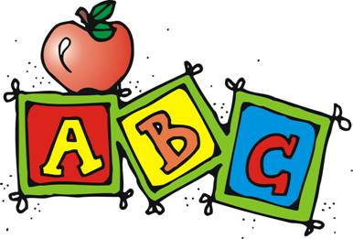
Homework Policy

Kindergarten homework is created to reinforce the concepts that have been taught at school. It will be helpful for you to have pencils, crayons, scissors and glue/glue sticks available for your child to complete assignments.
Kindergarten homework includes:

*Practice flashcards and read for 20 minutes each night - you reading to your child and your child reading to you ☺ 

* Reading book bag (books and directions are inside the bag)

*Alphabet sheets (2 per letter)

*Math homework sheets (several times each month)

The orange homework folder should be returned to school every Monday. Other assignments should be completed the night they are sent home, if possible.
